**File Created By Sayan Saha (**[**sayansaha00876@gmail.com**](mailto:sayansaha00876@gmail.com)**)**

**Week 4 : Mandatory Exercise 6 : JWT Hands-On :-**

**(All required execution screenshot + API testing using Postman)**

**1. Web Security error**

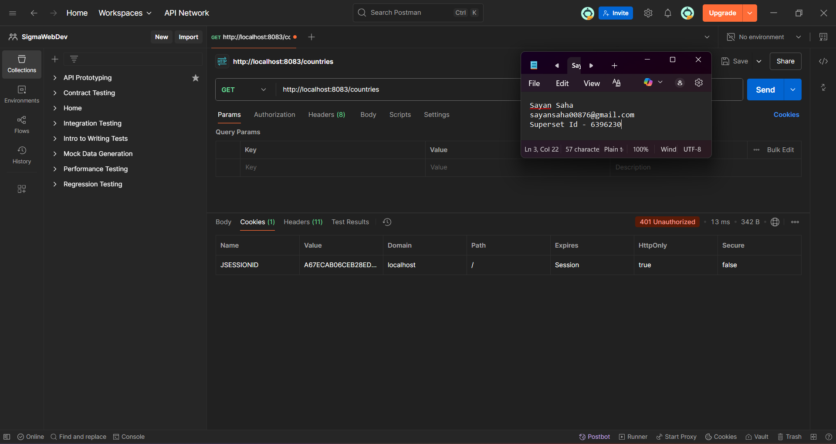

**2. Response using the correct user :**

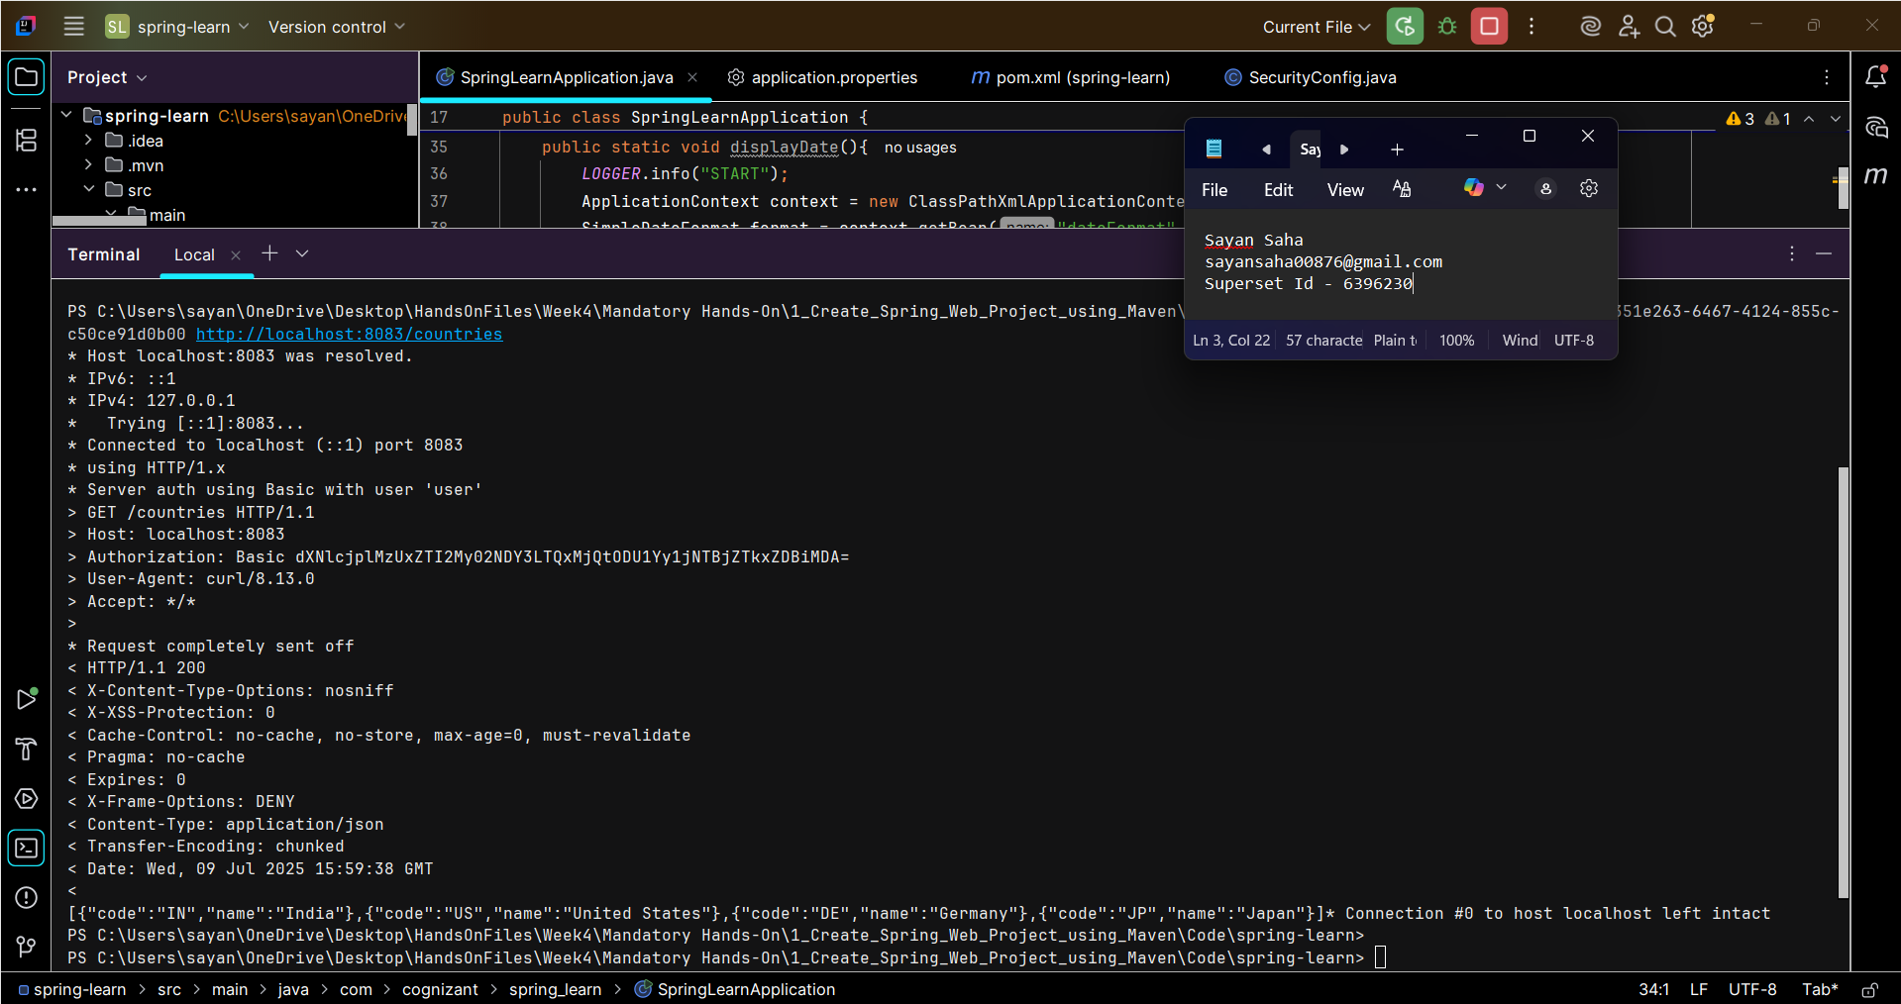

**3. Response using given userid and password:**

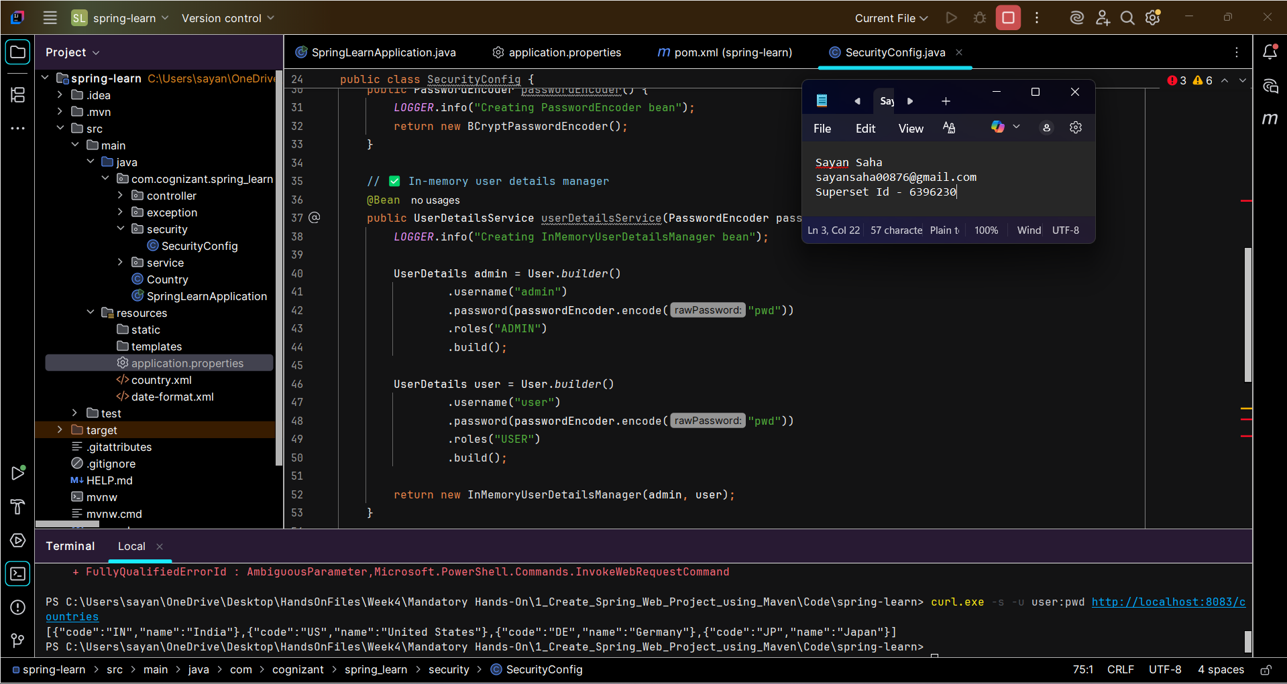

**4. Empty token:**

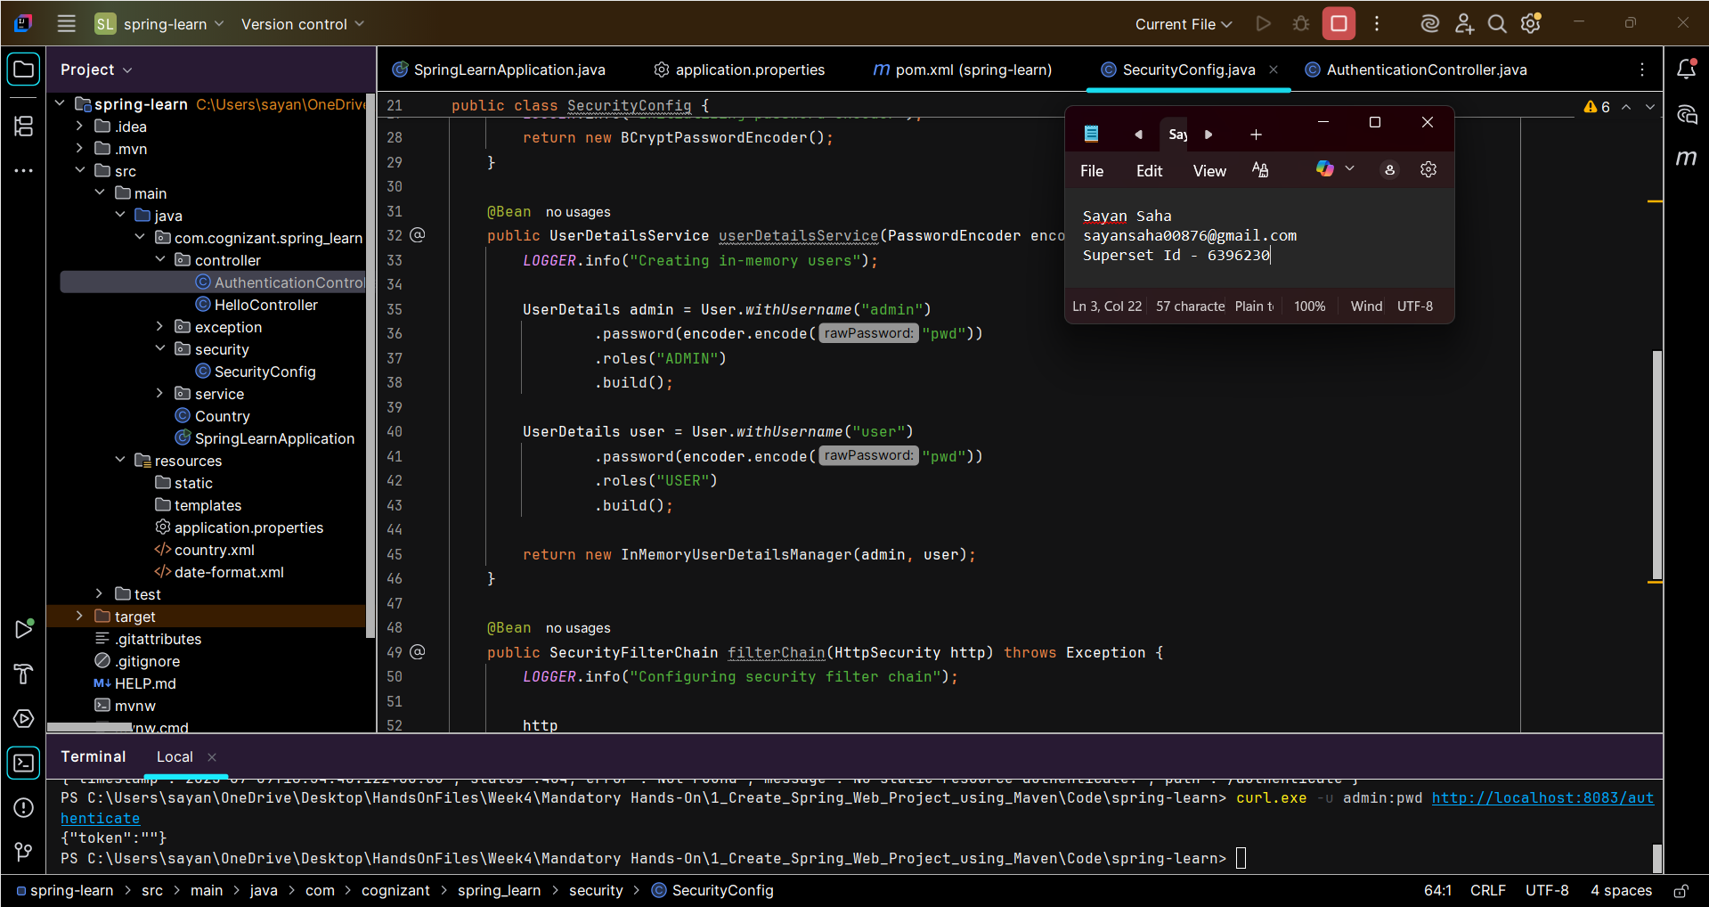

**5. Authentication logs :**

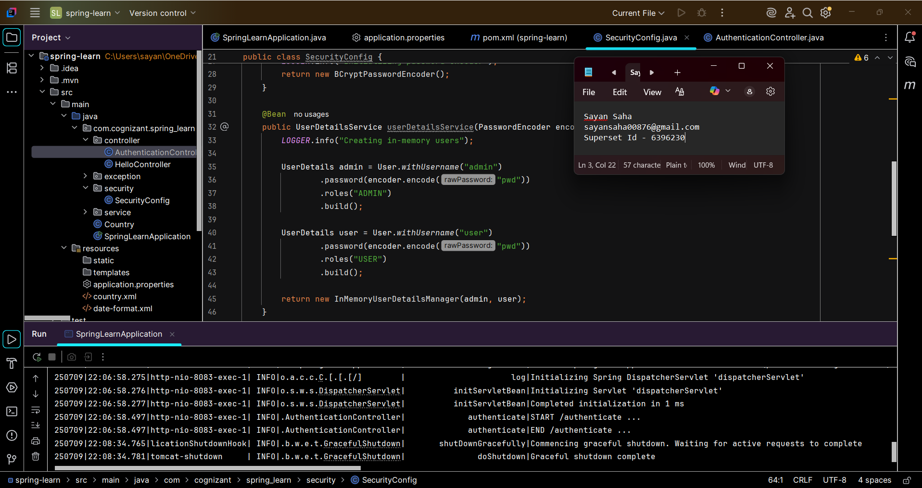

**6. Generate JWT token:**

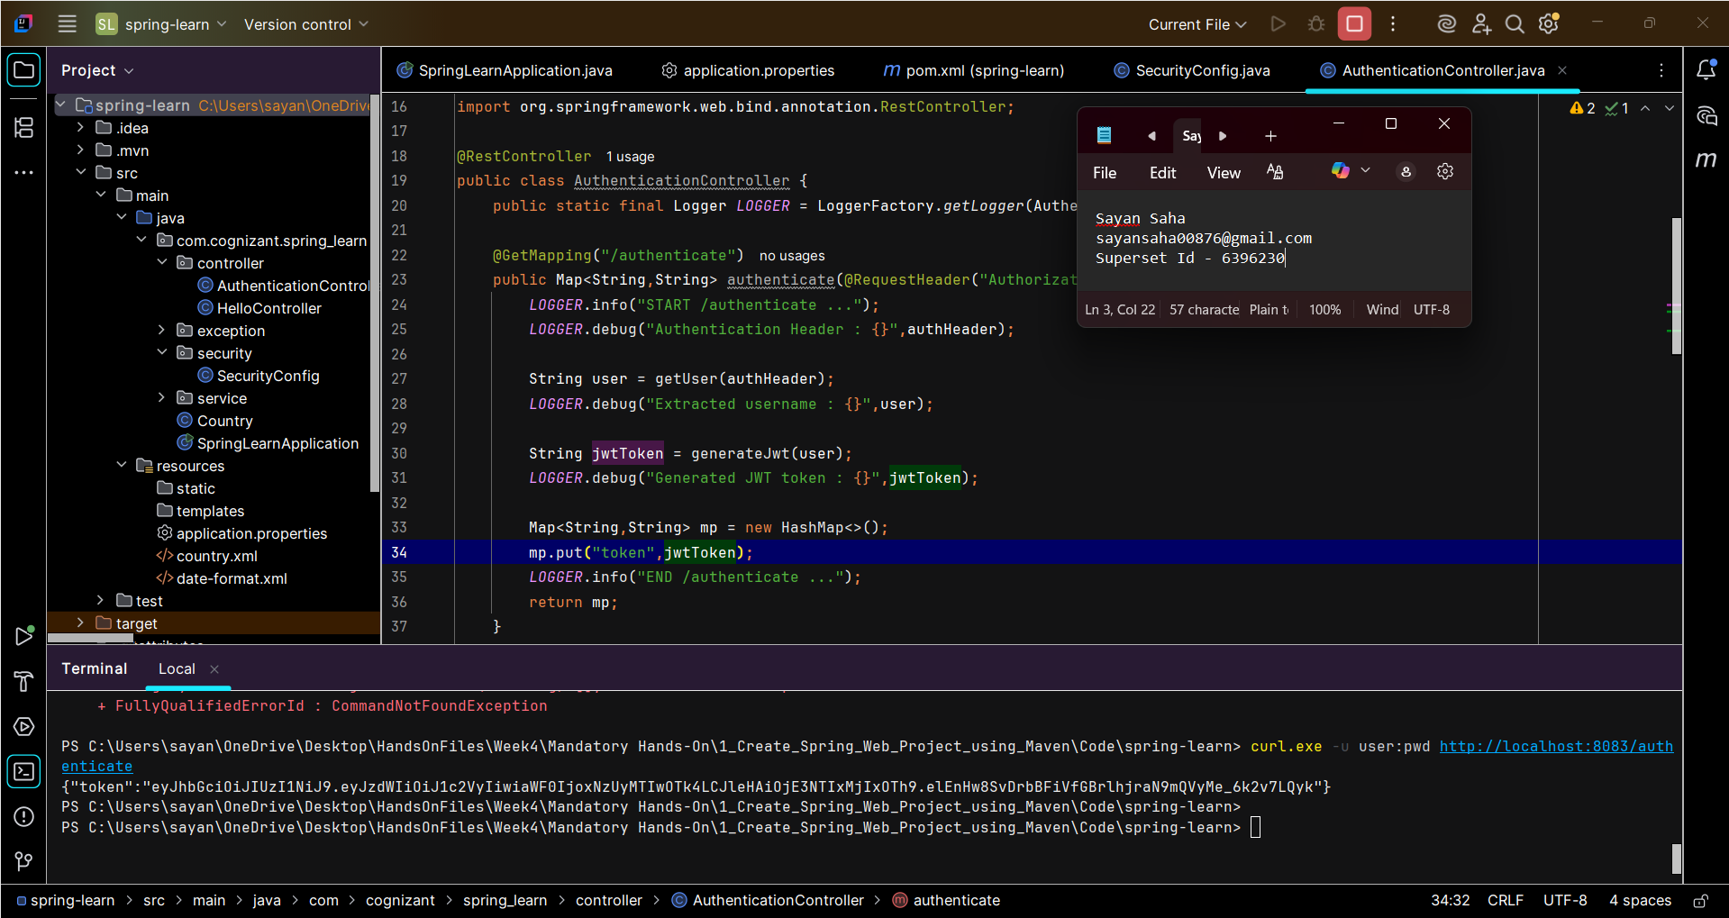

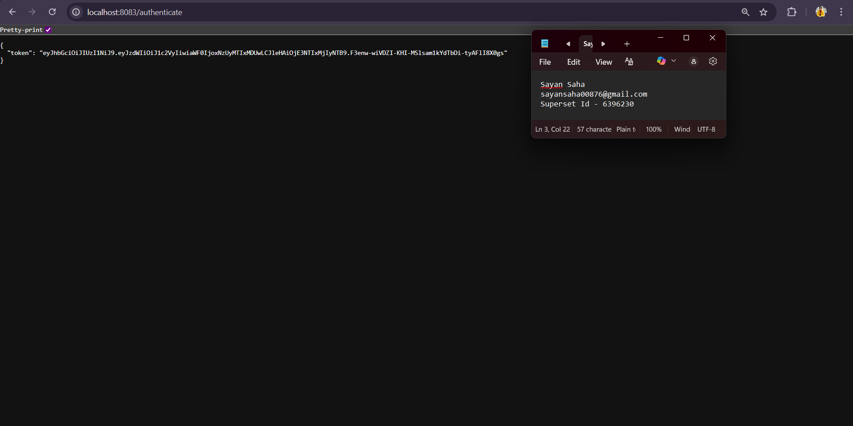

**7. Authorization based on JWT:**

